|  |  |
| --- | --- |
| Implemented in PythonBetter CDN connectivity and Content Management | Freedom to implement your own rules and does not require much setup. |
| **Django is based on loosely coupled architecture** | Flask is lightweight. This makes Flask a great choice for end-pointing, querying, and pipelining. . |
| Security | One of the most popular and most ignored sides to data science are is **Data Flow** which can be done easily with flask |
| A micro web framework written in Python | A web framework built on Python |
| Easy to learn with straightforward implementation | Open-source and accessible but follows the MVC pattern (Model View Controller), which often confuses beginners |
| Fewer lines of code | Lines of code are larger than Flask |
| Primarily used by top companies like Netflix, Reddit and Mozilla | Companies like Pinterest & Instagram use this framework |
|  |  |

Django Vs Flask in Data Science

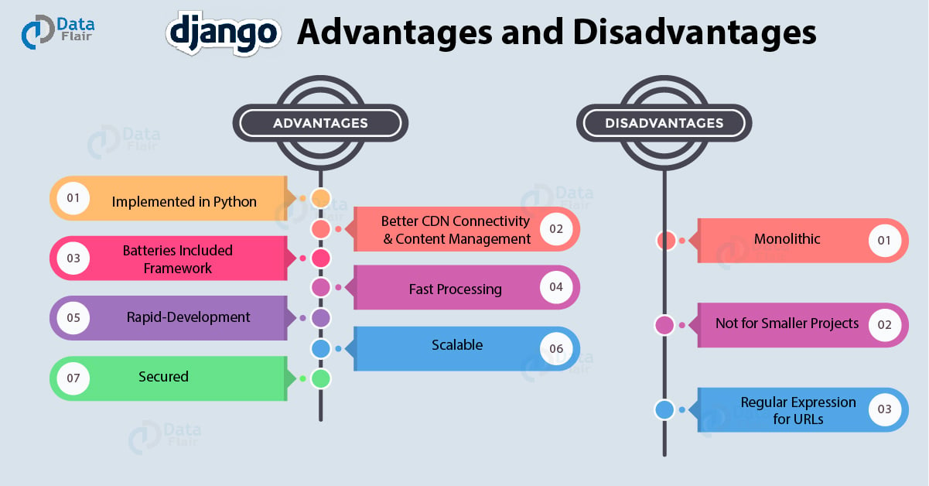

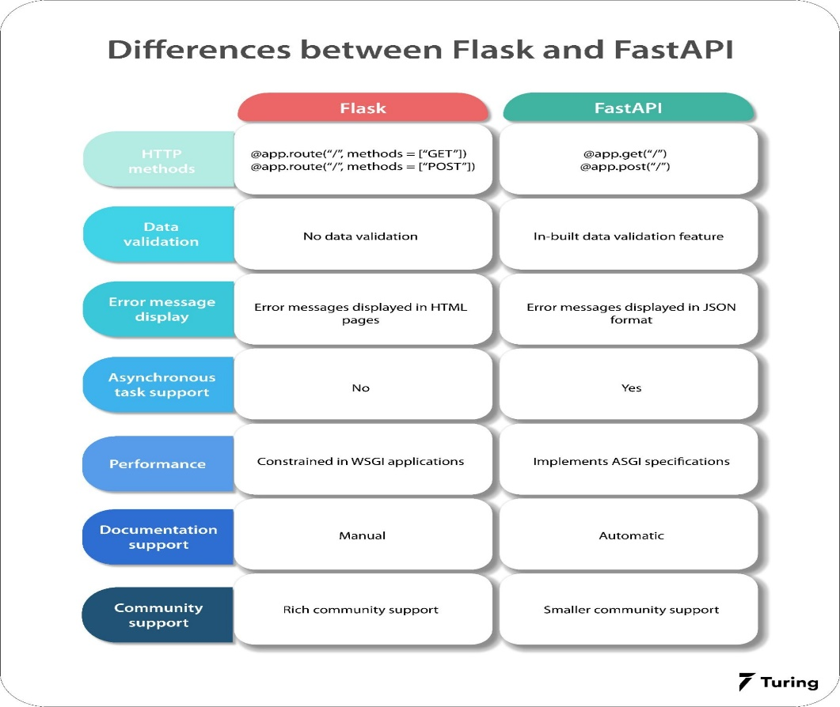

REFERENCES:-

<https://data-flair.training/blogs/django-advantages-and->disadvantages/

https://towardsdatascience.com/django-or-flask-recommendation-from-my-experience-60257b6b7ca6